**Shell – Final Case Study Assessment**

**Submitted by**Employee Name: Omeir Fawaz [Omeir.Fawaz@shell.com]  
Employee ID: 654865  
Date: 28th August 2023

**Scenario**Streamline Solutions Inc. - Optimizing Software Deployment

**Problem Statement**  
Implementing a Seamless CI/CD Workflow for a Spring Boot Application using Azure Boards, Azure, Git, Maven, Docker, GitHub, GitHub Actions

**Background**Streamline Solutions Inc. is a dynamic technology company specializing in cutting-edge software solutions. The company is developing a sophisticated Java Spring Boot application designed to revolutionize user experience. To ensure a swift and error-free software deployment process, Streamline Solutions is seeking to establish an efficient Continuous Integration and Continuous Deployment (CI/CD) workflow.

**Activities**

1. Create Project

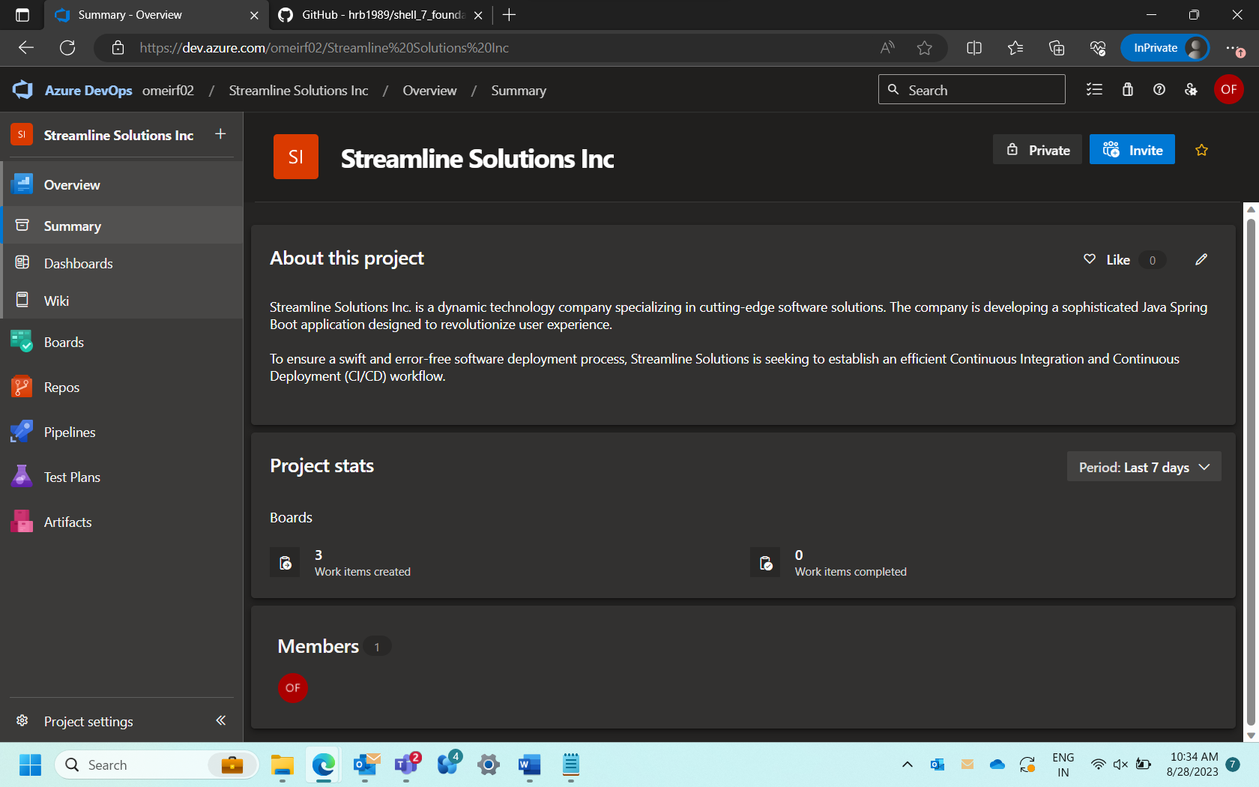

1. Create Epic

User Management

1. Create Product Backlog

1. Create Sprint Backlog

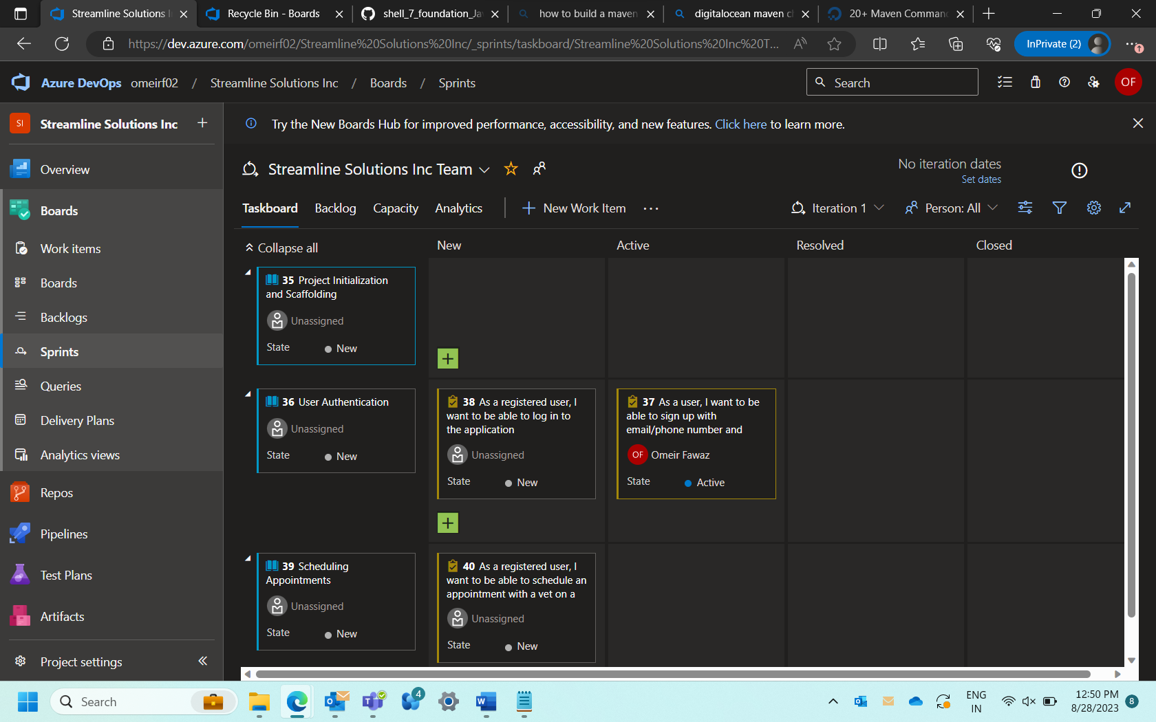

1. Create User Stories

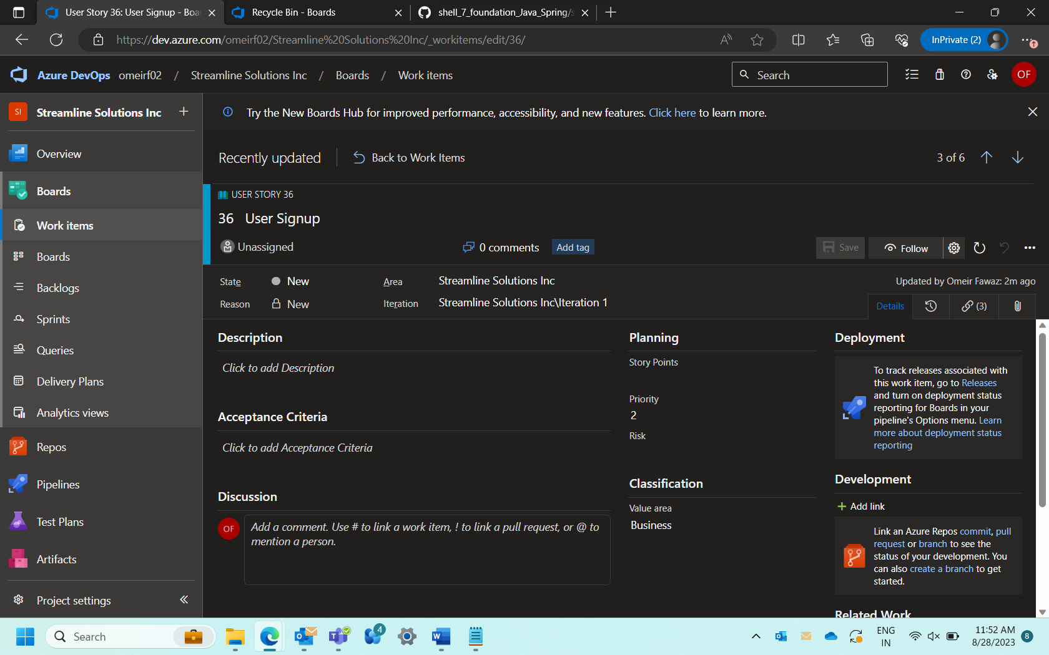

1. Create Tasks

1. Create Test Cases

1. Create Defects

Creating VM

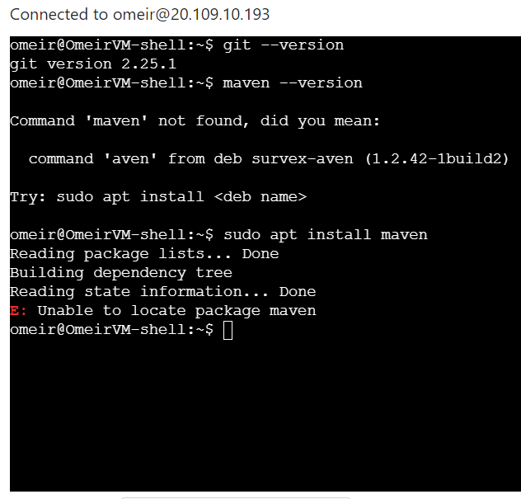

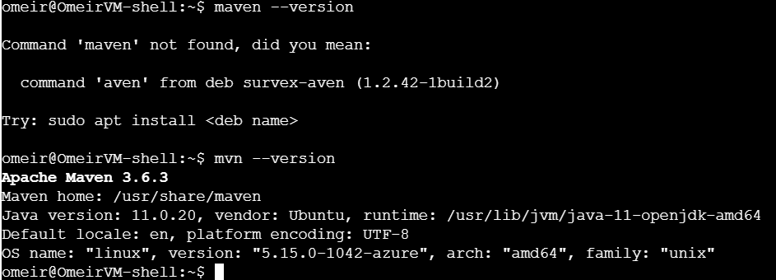

Install Docker

sudo apt update

sudo apt install apt-transport-https ca-certificates curl software-properties-common

curl -fsSL https://download.docker.com/linux/ubuntu/gpg | sudo apt-key add –

sudo add-apt-repository "deb [arch=amd64] https://download.docker.com/linux/ubuntu focal stable"

apt-cache policy docker-ce

sudo apt install docker-ce

sudo systemctl status docker

docker

docker run hello-world

Clone Repository

Installing Maven and Building App

mvn install -DskipTests

Running App

java -jar target/spring-petclinic-3.1.0-SNAPSHOT.jar

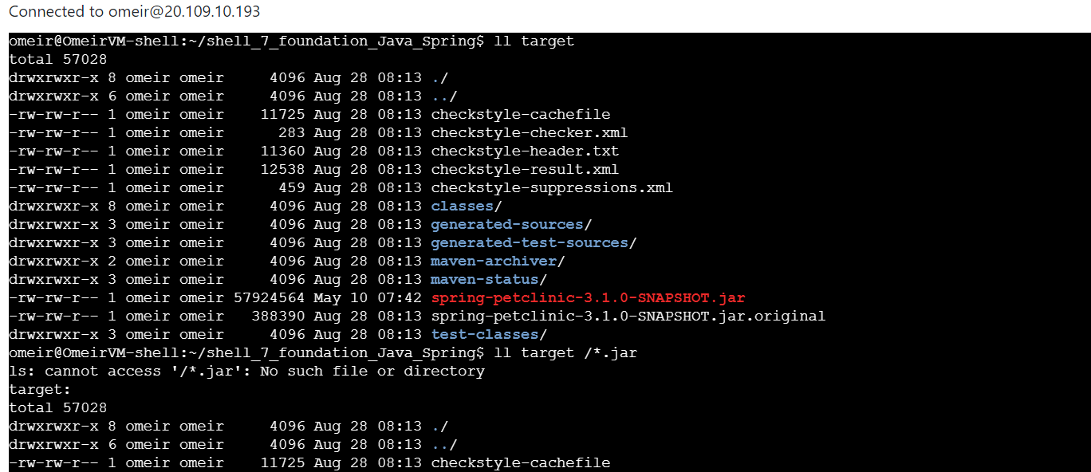

Add Feature (my name)

Build Docker container

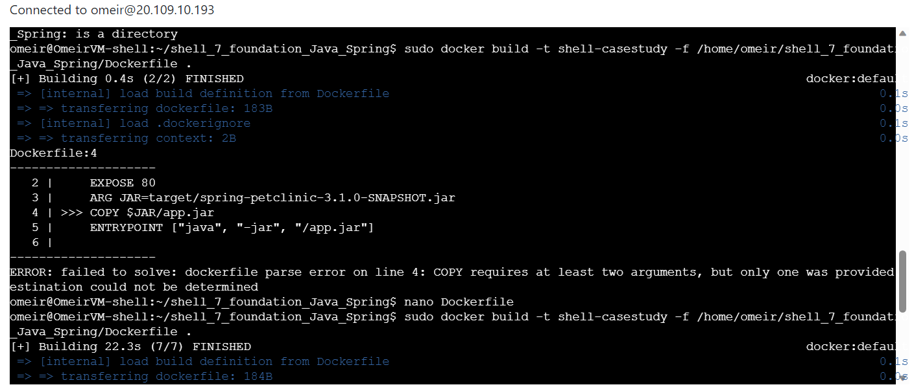

Log in to Docker Hub

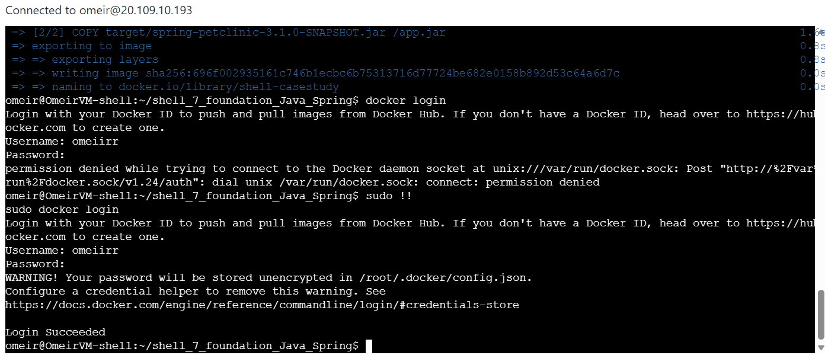

Push to Docker Hub

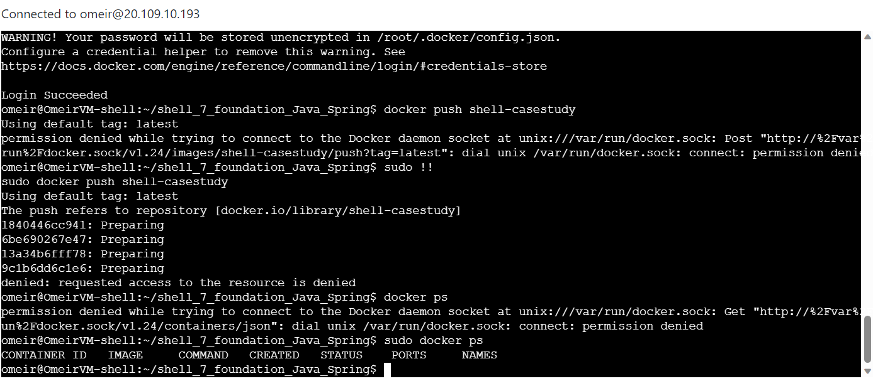

Create Web App

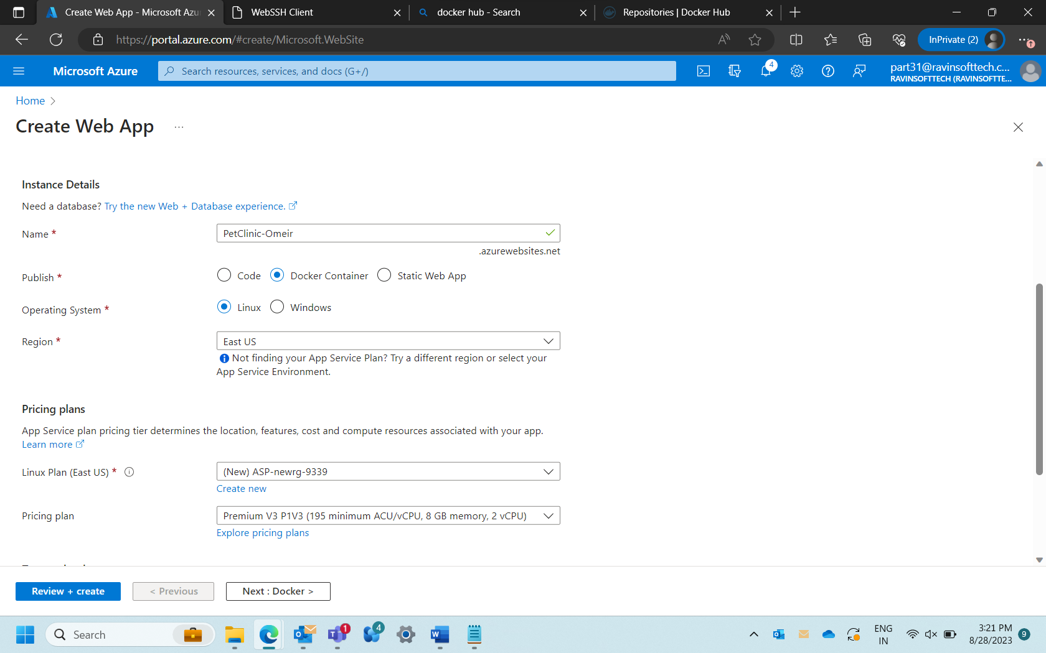

Deployed web app

**GitHub Actions**

Failed CI/CD Workflow

Successful CI/CD Workflow

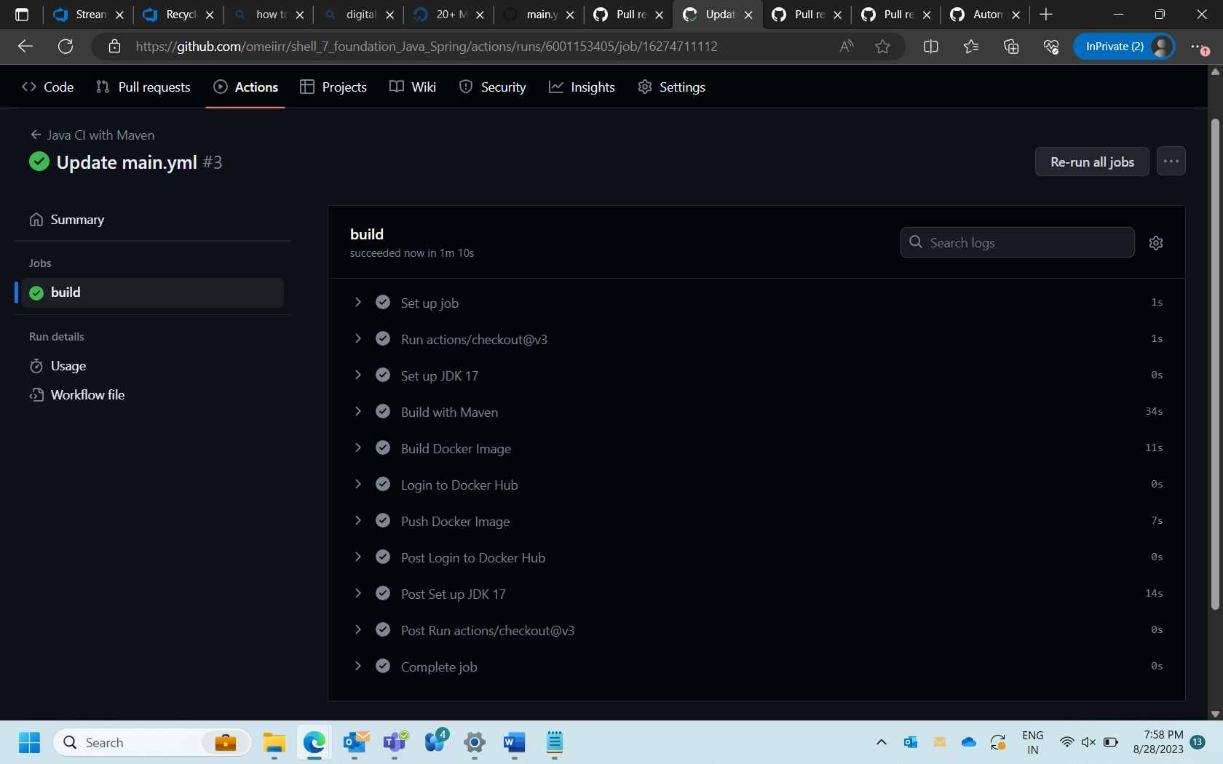

Raise PRs against the parent repository

PR 1:

PR 2:

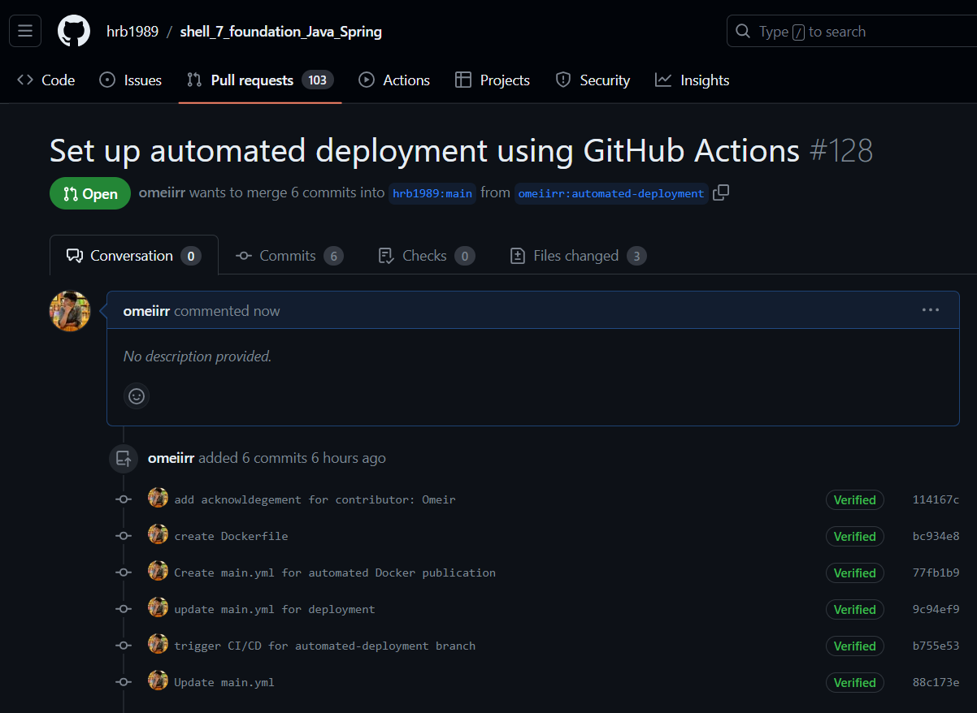

Regarding Task 11:  
New look and feel of app unable to be reflected in the deployed app as the VM and web app were shut down on admin level. However, functionality is complete.